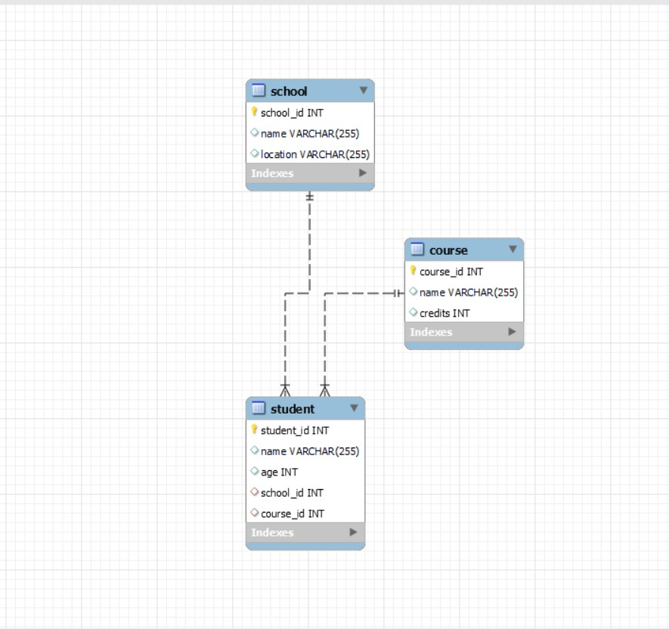

-- Create the university database

CREATE DATABASE university;

-- Use the university database

USE university;

-- Create the school table

CREATE TABLE school (

school_id INT PRIMARY KEY,

name VARCHAR(255),

location VARCHAR(255)

);

-- Insert 10 records into the school table

INSERT INTO school (school_id, name, location) VALUES

(1, 'School of Science', 'Science City'),

(2, 'School of Arts', 'Art Street'),

(3, 'School of Engineering', 'Tech Avenue'),

(4, 'School of Business', 'Business District'),

(5, 'School of Medicine', 'Health Campus'),

(6, 'School of Law', 'Legal Plaza'),

(7, 'School of Education', 'Learning Lane'),

(8, 'School of Music', 'Melody Square'),

(9, 'School of Agriculture', 'Farmville'),

(10, 'School of Social Sciences', 'Society Square');

-- Create the course table

CREATE TABLE course (

course_id INT PRIMARY KEY,

name VARCHAR(255),

credits INT

);

-- Insert 10 records into the course table

INSERT INTO course (course_id, name, credits) VALUES

(101, 'Mathematics', 3),

(102, 'History', 4),

(103, 'Computer Science', 4),

(104, 'Physics', 3),

(105, 'Marketing', 3),

(106, 'Biology', 4),

(107, 'Economics', 3),

(108, 'Chemistry', 4),

(109, 'English Literature', 3),

(110, 'Psychology', 3);

-- Create the student table

CREATE TABLE student (

student_id INT PRIMARY KEY,

name VARCHAR(255),

age INT,

school_id INT,

course_id INT,

FOREIGN KEY (school_id) REFERENCES school(school_id),

FOREIGN KEY (course_id) REFERENCES course(course_id)

);

-- Insert 10 records into the student table

INSERT INTO student (student_id, name, age, school_id, course_id) VALUES

(1, 'John Doe', 20, 1, 103),

(2, 'Jane Smith', 22, 2, 105),

(3, 'Bob Johnson', 21, 3, 101),

(4, 'Alice Williams', 23, 4, 107),

(5, 'Charlie Brown', 20, 5, 106),

(6, 'Eva Davis', 22, 6, 104),

(7, 'Mike Miller', 21, 7, 109),

(8, 'Sophie Wilson', 23, 8, 110),

(9, 'David Lee', 20, 9, 108),

(10, 'Linda Chen', 22, 10, 102);

Select * from school;

select * from student;

select * from course;

/*1) list all schools along with their locations*/

ANS select * from school;

/*2)Find the names and credits of all courses*/

ANS select name ,credits from course;

/*3) Retrieve the names and ages of all students*/

ANS select name, age from student;

/*4)Get the details of the student with ID 3*/

ANS select * from student where student_id=3;

/*5)List the courses and their credits offered by the 'School of Engineering'.*/

ANS

Select sc.name as school_name , c.name as course_name ,c.credits as course_credit from course as c

inner join student as s on c.course_id=s.course_id

inner join school as sc on sc.school_id=s.school_id

where sc.name="school of engineering";

/*(6)Count the number of students in each school*/

ANS

SELECT sc.name AS school_name, COUNT(*) AS student_count

FROM student s

JOIN school sc ON s.school_id = sc.school_id

GROUP BY sc.name;

/*(7) Find the average age of students.*/

ANS

select * from student;

select avg(age) as average_age from student;

/*(8)Retrieve the names of students along with the names of their schools and courses.*/

ANS

select s.name as student_name,sc.name as school_name, c.name as course_name from student as s

inner join school as sc on s.school_id=sc.school_id

inner join course as c on s.course_id= c.course_id;

/*(9)List the courses with more than 3 credits.*/

ANS

select * from course;

select name from course where credits>3;

/* 10)Get the names of students who are enrolled in courses with less than 4 credits.*/

ANS select * from student;

select * from course;

select s.name as student_name, c.name as course_name , c.credits as course_credits from student as s

inner join course as c on s.course_id=c.course_id where c.credits<4;